Costea Raul- pastor at Hope Church Draganesti-Olt, Romania / RESO Ministry Coordinator

Web Site
www.bisericasperanta.ro/eng

Contact:
Str Nicolae Titulescu, Nr 166, Drăgăneşti-Olt, Olt county, Romania
+40 249 466 810

RESO

Spreading
The Gospel
In Southern
Oltenia

Just as John the Baptist was challenged by the Pharisees to answer their question
“Who are you?" so I was challenged this month, through personal devotion, through a Nehemiah seminar taught by Nelu Sofrac, and other methods.
God challenged me to be focused on my role as mission coordinator and evangelist in which He had called me. Under the guidance and direction of the Holy Spirit, my activities and visits had an evangelistic purpose.

This month I was asked by members of the church to visit them. I did not decline the invitation, but I expressed my desire for every member that I will visit to invite other friends or neighbors to hear the Gospel.

Also, we completed a series of sermons “Christ of Scriptures” and I continued to equip workers for evangelism and mission.
There were many situations that brought me much contentment, but I'd like to share with you the experience I had with brother Sorin Caragea. I visited his study group of neighbors and God made possible an evangelistic conversation with a person that generated an interaction with other people present there. Sorin wants to be equipped with knowing how to present Christ to people. He observed my words, gestures, and approach. At the end of the visit he said, "Brother Raul, you have taught us many lessons about evangelism, but none compare to this lesson."
Horatiu is the man that I spoke with. He is a man of influence in our city, and many people believe to be his disciples. Pray for him to open his heart for salvation!

Pray for me to remain focused in ministry, according to the gifts God gave me, to know when I should say “yes” to some ministry activities, when to say “no”.
Thank you for the encouragement and support I receive from you. God bless you!

Costea Alexe- Comani
In May we continued to work for the glory of God.
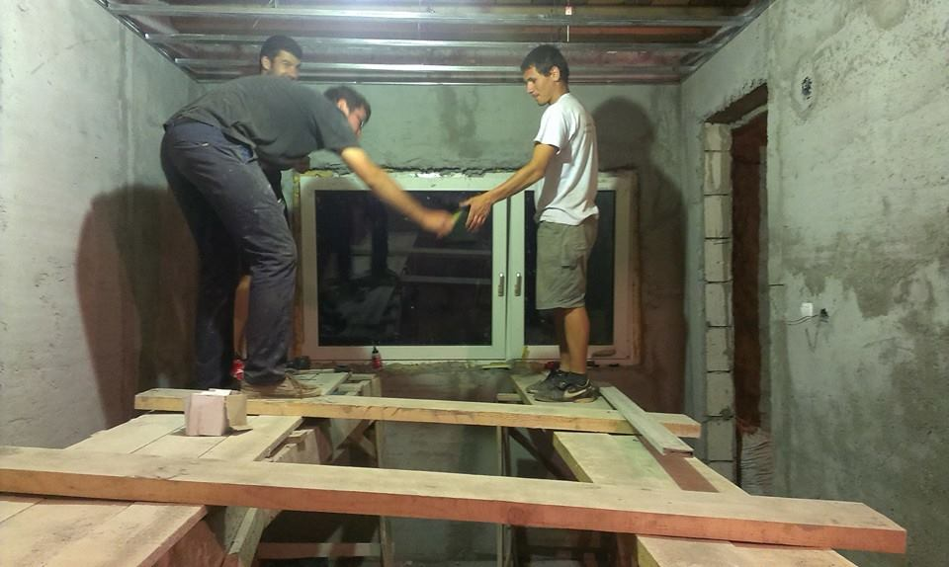
Last month I asked you to pray for Jenny and Cornel. After 22 years of living together illegitimately, they expressed their desire to put their relationship in order. We were glad at that time, but their decision was hindered by several difficult situations. The evil one is not sitting still. God gave me the desire to get involved in terms of obtaining some medical papers they needed. Please continue to pray that God will give us victory.
We were visited by Brother Lenny Loe and his wife Isabel and together we organized a meeting for women. It was a great blessing for them. Again they heard the Good News of God and the personal testimonies of our brothers. Praise the Lord!
A great joy to our family was also celebrating 10 years of marriage. God may be blessed!
I attended a seminar with Brother Nelu Sofrac from Alba Iulia, and I have been greatly helped to put some things I knew about mission work and church planting in order.
Pray for:
- Wisdom in working with people
- Protection for our family
- Kids Camp in August
- A worship leader in church
- Completion of construction work
- A minibus for our ministry
- Corina, Onita, Leana, Nicusica, Paulina, Marinica, Ionut, Gabii, people who come regularly to church

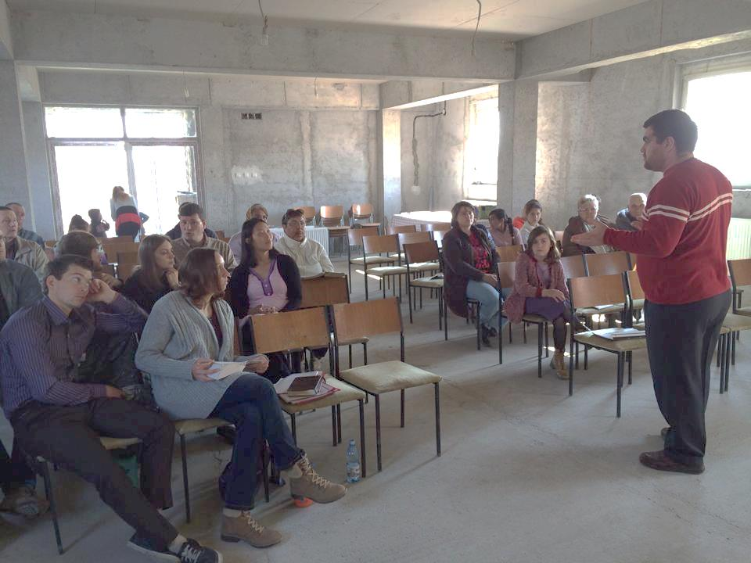
Dumitru Mircea- Corabia
In May, we understood, again, that focus on a particular area is very important for efficiency in God’s ministry. When I moved to Corabia, we prayed that God may work in all areas. I evangelized in the central area and in a few neighborhoods, but, little by little, God directed us to a part of downtown, an area called Mahala. I started to visit the area and prayed for each street and for the people we met on the street.

Mr. Constantin is one of the people who, last month, decided to follow Jesus. Every week we have a meeting at his house to study. This month he brought a friend to our meeting. Pray for him, that God will give him light to understand the difference between faith and religion.

This month, Dan began to come to church. He was a man who always said he was "a good man” and he does not understand why God gave him a serious illness. He has a blood infection. In May he suffered five strokes. When he was released from the hospital, I visited him and I noticed that his speech was partially affected by the stokes. He testified that he is a sinful man and yet God kept him alive and kept him from being paralyzed after the stroke.

Mrs. Doina amazes me every week. She brings new people every Sunday to our worship meetings. The last man she invited is named 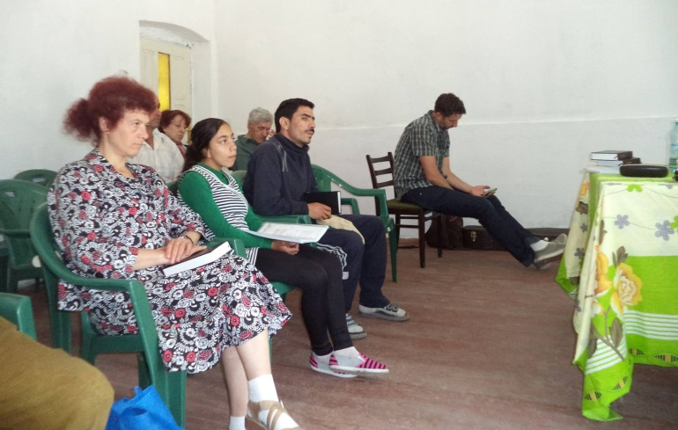Mircea. He used to attend a church in another city.

Pray for the June 19 event that we will organize with Luis Palau Association. It will be an evangelistic event for families and young people.
Plead with God for all who will hear the gospel to believe and to be born again.

Serban George- Stoenesti, Farcasele

We give thanks to God for this month for He was with us and He keeps his promise: “Never will I leave you; never will I forsake you.”'
I thank God that he put people to work together for the same goal, even if some are far away. Prayer has no boundaries; it is His work to arrange everything.
For two weeks I attended a training seminar in church planting two days a week, held by brother Nelu Sofrac, mission coordinator at Alba Iulia Baptist Church. It was a time where I learned the importance of prayer and teamwork and, not least, the importance of dependence on God.
One nice thing that happened this month was my experience with Florin. Earlier this year I met Florin, and we had weekly meetings to study the Bible with other young people. After a few months, Florin stopped coming to our group. When he was asked why he gave just unfounded reason. We realize the pressures that were on him from other boys in town because he decides to follow the Lord. I continued to pray for him, and I visited him again after two months. Florin returned to our group and he wants to know more about God. Pray with us for this 19-year-old boy who needs Jesus, to be firm in his decisions!
At the end of a Sunday service, I prayed with a woman who regularly attends church, and she confessed that the Lord forgave her sins and she is a different person now. She also expressed her desire to be baptized and asked me to talk to her husband about her decision. Later, I had the opportunity to meet him and he said that he agrees and is impressed by the positive change in his wife.
Pray for this family, may the Lord touch her husband and her children!

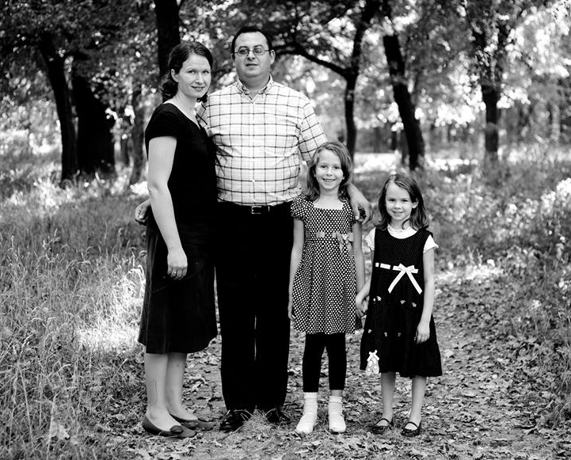
Thank you for all of you who have prayed for Dana’s medical intervention. You have been a real support in this situation. Now she feels better, thank God. In one month we will go to Bucharest for another medical visit.
Thank you again for your love and prayer! Bless you!

Berechet Octavian- Maruntei
I want to begin by expressing my great gratitude for your support, both in prayer and encouragement. This intercession fuels our work and the Lord is so faithful to provide us with increasing enthusiasm and joy for the work he has called us to for his glory. This month, we continue to do kids ministry and discipleship with a few boys in Maruntei. These efforts are part of a much greater vision to spread the gospel to this entire community and beyond.
While we can see the Lord at work in the minds and hearts the people here, we have also met great opposition in the form of longstanding religious tradition. Many here are eager to hear about Jesus and the salvation that he freely offers. However, this great message contradicts some traditional religious values and, thus, there is a great deal of pressure to reject the gospel and return, instead, to old ideals and beliefs.
We saw this conflict portrayed very clearly in the lives of one family within our church. Both the mother and father began to attend Sunday services and their children regularly joined the kids club program. We were devastated to learn that the town’s orthodox priest approached this family, stating that he would not baptize their infant child if they continued to remain within our congregation. And, while we believe that baptism is a physical expression of an individual’s heart to die to self and pursue the Lord, rather than a tradition to be carried out in infancy, this family decided to no longer attend our church. 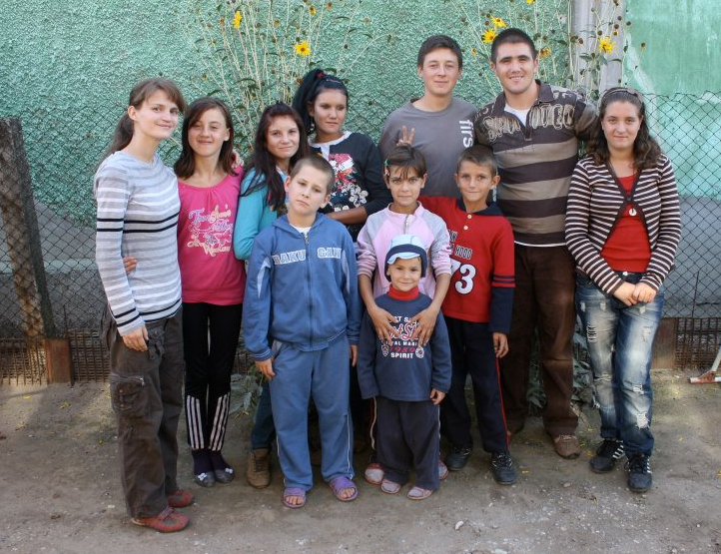
We ask that you join with us in praying that the truth, grace and freedom of the gospel shine ever more brightly amidst this area’s struggle between faith and tradition.
Also, please pray, specifically, for the family mentioned above—that the Lord will continue to reveal himself to them and that they will experience him and his great love for them. Lastly, please pray that God will continue to strengthen, encourage and equip us for his purposes and glory. Thank you, again, for the love that you have shown us and for allowing me to share both the joys and struggles that we currently face. Words fail to express how deeply your prayer and support is appreciated and needed. I pray that the Lord will richly bless you and that he will continue to reveal himself in your own life.

Ileana Maria- Hope for the Community Organization
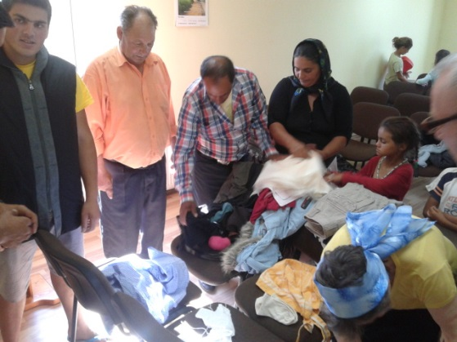
By God's grace, Association’s projects continued to be unfolding this month. During the Afterschool program, many children continued to attend daily for help with their homework.
Thank you to those who donated this month to offer children sandwiches and a dessert. Through the implication of HOE Netherlands Organization, RESO ministry received, this month, a truck with clothes, shoes, toys, canned, school benches to be used in children ministry and also other goods. We thank God and we thank our partners for this donation.
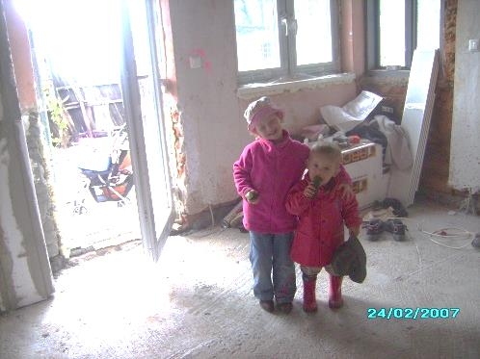
Stoica Marian- Daneasa
God is good and He deserves to be praised!
We thank God because His goodness continued to be poured out on people in Daneasa.
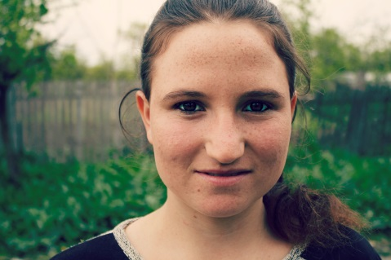
Mariana, a teenager, who a year ago was a simple girl participating in a kids group, has now begun working with other kids. We are glad to see the fruit of our ministry. We pray that while Mariana teaches children about God, she may come to know more and more about Jesus, her Lord and Savior. We want to start new ministries in other areas of the town of Daneasa. Pray to find family and contacts open and willing to accept God.
Here, he founded a new prayer group of four women who come regularly to Hope Church programs in Drăgănesti-Olt. We meet every two weeks to learn more about God’s name and to learn to trust Him with our lives and our needs. Pray for these women to choose Christ, seeing that He answers their prayers!
We see God’s goodness in our family also. We are excited to welcome our third baby family that God has given us. It will be a busy period for us: ministry, moving into a new house, and then completing construction of the new house. In all this we trust in our Father's hand and we believe that He knows what we need. Pray for Andrea and her children when they will travel to Germany for the birth. May God prepare a safe flight, to strengthen Andrea and to arrive safely in Germany.

Opris Daniel- Coteana
We continued to do evangelistic visits and also we visited some brothers that I take close care of. My wife and I, we visited people and families who are interested in God and have made progress in acknowledging the teachings of the Bible. Also, children who come to our home want to know more about God. Lidia taught them Bible lessons and guided them to come to Draganesti church gatherings, and they came. But there is a danger that they will break their relationship with us, the church, once they grow older. In a Sunday evening service at Drăgănesti Church, following a call for repentance, a few people from Coteana expressed the desire to be baptized.
Being that Coteana is a poor area, we have tried to help deliver materials to some families. We distributed several boxes with used clothes to those in need, and we continued to give some food to a few families with children in need of school lunchesAlso, I was able to procure the medicines needed for a paralyzed woman.
We want to establish a church here for the glory of God.
Thank you to all who read this newsletter and who will pray for us!

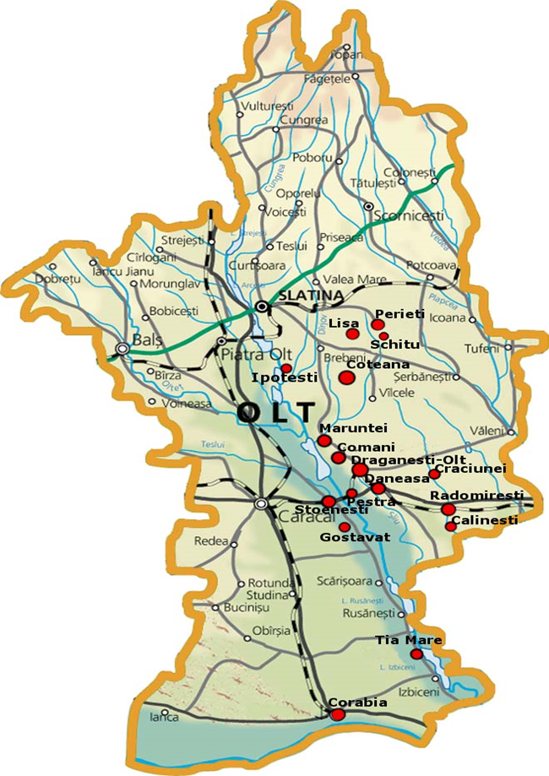
Click on the image bellow to visit the Hope Church website!

